IRISH ASSOCIATION
OF SNOWSPORTS INSTRUCTORS

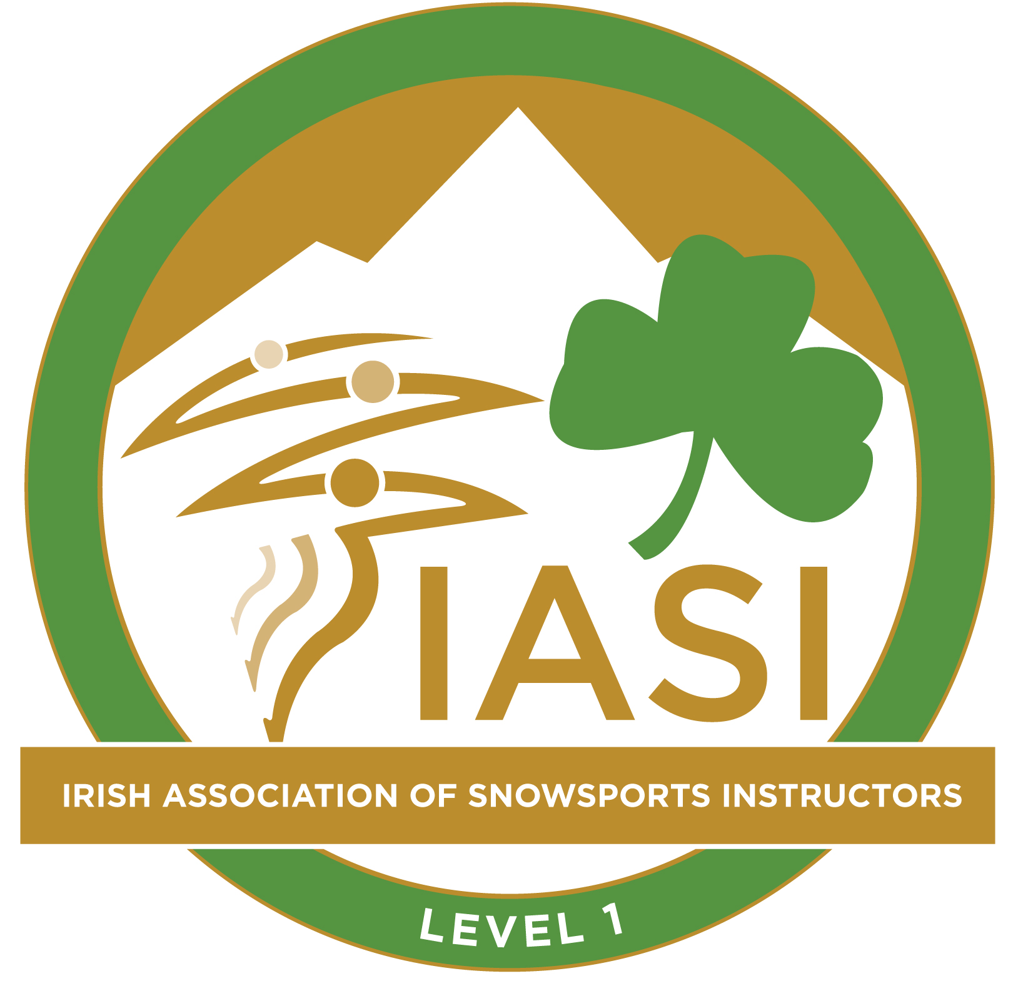

Alpine Level 1 Ski Instructor Award

Student Workbook

Version 4, July 2022

 |  | Contents:
Page No.
1.0 | Overview of the Award |  |  |  | 02
 |  |  | 1.1 | Holders of the award will have | 02
 |  |  | 1.2 | Limitations of the award | 02
 |  |  | 1.3 | Using the workbook | 02
 |  |  | 1.4 | Pathway to Alpine Level 1 Ski Instructor award | 03
 |  |  | 1.5 | Technical assessment criteria | 04
 |  |  | 1.6 | Teaching assessment criteria | 05
 |  |  | 1.7 | Resources | 06
 |  |  | 1.8 | Sample programme | 07
2.0 | Day One (or equivalent hours) |  |  |  | 08
 |  |  | 2.1 | Outcomes and notes | 08
 |  |  | 2.2 | Basic Principles model | 08
 |  |  | 2.3 | IASI Skills Model | 09
 |  |  | 2.4 | PEAR Model | 10
 |  |  | 2.5 | Core Skier Development Model | 11
3.0 | Day Two (or equivalent hours) |  |  |  | 12
 |  |  | 3.1 | Outcomes and notes | 12
 |  |  | 3.2 | Analysing performance | 12
 |  |  | 3.3 | Teaching styles | 13
 |  |  | 3.4 | Teaching Styles review using PEAR Model | 14
 |  |  | 3.5 | Diamond Model of Skill Acquisition | 14
 |  |  | 3.6 | Session planning | 15
4.0 | Day Three (or equivalent hours) |  |  |  | 18
 |  |  | 4.1 | Outcomes and notes | 18
 |  |  | 4.2 | Teaching Session review using PEAR Model | 19
 |  |  | 4.3 | Technical and Teaching mid-course review | 20
5.0 | Day Four (or equivalent hours) |  |  |  | 21
 |  |  | 5.1 | Outcomes and notes | 21
 |  |  | 5.2 | Review of BP, CSD & PP | 21
 |  |  | 5.3 | The assessment process | 22
6.0 | Day Five (or equivalent hours) |  |  |  | 23
 |  |  | 6.1 | Outcomes and notes | 23
 |  |  | 6.2 | Developmental activities | 24
 |  |  | 6.3 | Teaching Session Planner | 25
7.0 | Day Six (or equivalent hours) |  |  |  | 26
 |  |  | 7.1 | Outcomes and notes | 26
 |  |  | 7.2 | Student teacher delivery – review notes | 26
 |  |  | 7.3 | Individual action points – technical & teaching | 27
 |  |  | 7.4 | IASI Qualification pathway – Alpine Levels 1 to 4 | 28

- Overview of the Award

1.1 Holders of the IASI Alpine Level 1 Ski Instructor award will have;

- An all round parallel skiing performance on artificial surfaces or snow.
- A good understanding of modern ski technique, equipment and skier’s development.
- The ability to plan and deliver skiing sessions to all skiing standards up to parallel.
- Demonstrate sound group management with a good knowledge of safety requirements for artificial venues including indoor snow domes.

NB: Please note that a more detailed breakdown of the technical and teaching assessment criteria is detailed on the following pages.
,
1.2 Limitations of the award:

- Holders of the IASI Alpine Level 1 Ski Instructor award are qualified to instruct skiers on artificial surfaces, including indoor snow domes (closed environment).
- Holders are NOT qualified to work “on snow” in the open mountain environment.

1.3 Using the workbook:

The workbook is designed to be used in conjunction with the IASI Manual covering key areas of the award and guiding you through the training and assessment.
The Educator will ask to see your workbook to help check and assess your understanding of the main themes.

Please note that IASI supply all workbooks in electronic format and encourage students to use electronic devices during the course to refer to it. Notes can be taken separately on electronic devices or in a traditional paper based notebook.

1.4 Pathway to Alpine Level 1 Ski Instructor award:

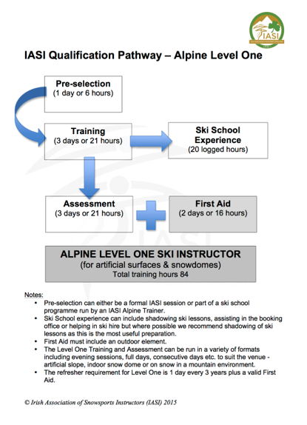

1.5 Technical assessment criteria:
The following criteria are broken down under the headings of Core Skier Development (CSD), Piste Performance, Switch Skiing and Additional Activities. It sets out what you as potential level 1 instructors need to "Show" by the end of the course.
CORE SKIER DEVELOPMENT
Show
- straight running using terrain to control speed with both skis flat
- plough gliding at a constant speed with ski tips close
- plough turns, using the shape of the turn to control speed and maintaining a similar size plough shape throughout
- plough parallel turns, matching the inside ski parallel at different phases of the turn (as requested by the educator), and continuing to steer the skis to the end of the curve, while maintaining an open stance
- basic parallel turns with and without pole plant, maintaining an open stance (similar distance between skis/feet)
- additional activities such a diagonal side slip (at a constant speed) and a stork turn with an late pick up of the inside ski
- good posture and balance throughout for all of the above

PISTE PERFORMANCE
Show
- short radius turns using a good blend of the steering elements to produce rounded skidded turns (simultaneous rotation of the skis/feet). Each descent should be rhythmic and flowing with good control of speed
- cleanly carved turns on easy terrain, with tails following the tips
- good posture and balance throughout for the above

SWITCH / BACKWARDS SKIING
Show
- ability to link a minimum of reverse plough turns down an easy blue piste
- effective posture and balance
- to ensure good vision the upper body will have rotation so turning effort won’t be only from the lower body

ADDITIONAL ACTIVITIES
Show
·Ability to side slip diagonally in both directions whilst maintaining accurate rotational
separation
- Stork turns - Showing the ability to pick up the tail of the inside ski from turn initiation and throughout the whole turn
1.6 Teaching assessment criteria:

Closed Environment
Client level – Up to basic parallel
- Teach CSD progression (Educator setting difficulties among the group e.g. creating scenarios)
- Demonstrate knowledge on how to develop through the CSD with appropriate progression and effective use of drills and exercises
- Ability to identify and explain the WHY, WHAT, HOW of each chosen drill or exercise
- Effectively use the P (plan) and E (execute) stages of the PEAR Model

PLAN
- a session appropriate to the learner’s needs and goals
- a logical progression of activities
- a session that has a beginning, middle and end

EXECUTE
- confident communication that focuses on the whole group and individuals within the group
- the ability to use a good mixture of explanation and demonstration
- the ability to give positive and corrective feedback either through telling or questioning
- the ability to use simple everyday language that is not overly technical
- the ability to adapt language to different types of client
- the ability to keep learners moving (MCA)

SAFETY
Know
- the 10 FIS Rules of Conduct¹ for skiers and boarders
- about accident procedure
- the different types of lifts encountered at artificial slopes and snow domes and how to introduce them

Show
- good group management during session delivered
- the ability to use and teach the FIS rules of conduct as required
- the ability to give clear instructions/directions to assist with management of learners
- awareness of other slope users
- good communication with other instructors delivering sessions as required
- good choice of terrain appropriate to the learners ability level

1.7 Resources:

1) 10 FIS Rules of Conduct for skiers & boarders
https://tinyurl.com/2s3x74vh
https://www.flipsnack.com/iasimanual/iasi-manual/full-view.html p122

2) Irish Association of Snowsports Instructors Manual https://iasisnowsports.ie/iasi-manual/

3) Irish Association of Snowsports Instructors Outcome Standards https://www.iasisnowsports.ie

1.8 Sample programme:

IRISH ASSOCIATION OF SNOWSPORT INSTRUCTORS
Alpine Level 1 Ski Instructor Course Programme

Day | Morning | Afternoon | Classroom | Support Programme
Day 1 | Basic Principles (BP) of skiing  Forces, Movements, Balancing, Steering | Core Skier Development (CSD)  Sliding to plough turning | Review of on slope content | BP, Skills Model, CSD and PEAR Model worksheets
Day 2 | Core Skier Development (CSD)  Plough parallel to parallel | Piste Performance  Short turns & carving  Analysing performance | Review of on slope content | Analysing Performance  DMSA  Teaching review & planning
Day 3 | Session Deliveries by students | Perform all areas | Review of on slope content | Individual mid course reviews  Teaching Session review
Day 4 | Revisit Basic Principles (BP) of skiing & analysing performance | Revisit Core Skier Development (CSD) | Review of on slope content | The assessment process  BP, CSD and PP review
Day 5 | Developmental Activities for CSD stages  Drills & exercises | Development of individual strengths & weaknesses in CSD & Piste Performance | Review of on slope content | Session Planning
Day 6 | Session Deliveries by students | Review of Level 1 course both technical & teaching | Individual results & action planning | Course review & IASI qualification pathway

NB: The Alpine Level 1 course runs in a variety of formats including 2 x 3-days and evening sessions. The programme above describes the course in the 6-day consecutive format. One day represents approximately 7 hours with this typically being 5 hours skiing and 2 hours off slope in the classroom. However this is only a guide and courses will vary slightly depending on the venue and format. The trainer will ensure that all the content is covered no matter what format is used.

- Day One (or equivalent in hours)
2.1 Outcomes and notes

Outcomes:

Relaxed and comfortable with your peers, trainer and course programme
- Understand the Basic Principles and the terminology used
- Enjoy some skiing at your own level
- Begin to understand Core Skier Development
- Ski CSD stages up to plough turning

Feedback and notes:

2.2 Basic Principles Model

You can find the Basic Principles Model and a detailed explanation here:
https://www.flipsnack.com/iasimanual/iasi-manual/full-view.html p12

What are the 4 FORCES that we interact with whilst skiing?

What are the 4 MOVEMENTS that we can make?

Describe BALANCING in relation to skiing

What are the 3 elements of STEERING?

Describe how they can be blended to produce different outcomes.

2.3 IASI Skills Model

You can find the IASI Skills Model and a detailed explanation here:
https://www.flipsnack.com/iasimanual/iasi-manual/full-view.html p26

What are the 4 core SKILLS that we teach according to the IASI Skills model?

What 2 aspects are required to enable skiers to perform the skills effectively?

How does ROTATION affect to turn shape.

Describe EDGING

Explain why being able to decrease edge angle can be just as important as increasing edge angle.

Describe PRESSURE CONTROL.

Explain 2 ways in which PRESSURE can be managed.

Explain why TIMING is important.

How can timing be altered to affect the outcome?

2.4 PEAR Model

You can find the PEAR Model and a detailed explanation here:
https://www.flipsnack.com/iasimanual/iasi-manual/full-view.html p104

Why make a PLAN?

What do you PLAN?

When do you PLAN?

What is the EXECUTION phase of a lesson?

What is the student doing during this phase?

What is the teacher doing during this phase?

Why might a plan need to be ADAPTED?

How can a plan be ADAPTED?

Will every plan/lesson need to be adapted?

Why do we need to REFLECT on a lesson?

When can we REFLECT on a lesson?

What questions can a teacher ask themselves regarding the lesson?

What questions can a student ask themselves regarding the lesson?

Is reflecting on a session only relevant to that session and that particular student? Can useful lessons be learnt that can be incorporated into different situations and scenarios?

2.5 Core Skier Development Model
You can find the Core Skier Development Model and a detailed explanation here:
https://www.flipsnack.com/iasimanual/iasi-manual/full-view.html p40

Core Skier Development phase | Task(s) | Basic Principles  (Which ones are the main focus?)
Straight Running | Skis flat allowing terrain to control speed
 | Straight run to plough
Ploughing | Plough glide at constant speed
Plough Turning | Small changes of direction moving both ski tips in desired direction
 | Developing corridor so that turn shape controls speed
Plough Parallel | Matching parallel late in the arc (after fall line)
 | Matching parallel earlier in the arc (around fall line)
Basic Parallel | Rounded curves using turn shape to control speed
Parallel using poles | Using a pole touch to aid timing and rhythm
3.0 Day Two (or equivalent hours)
3.1 Outcomes and notes

Outcomes:

- Ski CSD stages up to parallel using poles
- Ski Piste Performance short turns
- Ski Piste Performance carving
- Start to analyse performance

Feedback and notes:

3.2 Analysing performance

Analysing performance is effective and accurate when a clear and specific task has been set.
Use the following questions to help you analyse your own performance during a specific task or the performance of others in your group.
What was the task?

Was the task achieved? | If yes, what could be the next task to improve performance?
If no, why:
Was the task appropriate and specific?

Was the skier balanced? (fore/aft and laterally)

Were the skier’s movements appropriate regarding range/rate/timing?

How did the skis interact with the snow? (gripping, skidding, steering)

3.3 Teaching Styles
You can find a list of different teaching styles and a detailed explanation here: https://www.flipsnack.com/iasimanual/iasi-manual/full-view.html p147
Describe each style in a few words.
(You will be expected to be able to describe the styles indicated at the respective level. Of course, you can make notes on all the styles if you wish!)

Command
L1, 2, 3 & 4
Practice
L1, 2, 3 & 4
Reciprocal
L2, 3 & 4
Self-Check
L2, 3 & 4
Inclusion
L2, 3 & 4
Guided Discovery
L3 & 4
Convergent Discovery
L3 & 4
Divergent Discovery
L3 & 4
Learner Designed
L4
Learner Initiated
L4
Self Teaching
L4
3.4 Teaching Styles Review using the PEAR Model

Based on a lesson that you have taught/participated in/ observed use the PEAR model to review the teaching styles used.

Plan
Give a brief outline of the lesson
Which teaching styles were planned to be used? Why?

Execute
Which teaching styles were actually used?

Adaption
Were any of the teaching styles adapted or changed during the lesson? If so, what changed?

Reflection
Why were the teaching styles changed? Did it improve the lesson?
Which teaching styles worked well in the lesson?
Which styles didn’t work well? Why not?

3.5 Diamond Model of Skill Acquisition
You can find the Diamond Model of Skill Acquisition and a detailed explanation here:
https://www.flipsnack.com/iasimanual/iasi-manual/full-view.html p96

What is happening for the teacher and student in the KNOWLEDGE phase?

What is happening for the teacher and student in the MOVEMENTS phase?

What is happening for the teacher and student in the PERFORMANCE phase?

What is happening for the teacher and student in the FLOW phase?

3.6 Session planning

Pre-teaching session planning – collecting information

Initial information required:

- How many students will you be teaching?

- What is their age and gender?

- How long will the session be?

Once you have answered the above questions you should consider the following prior to planning the teaching session;

- What previous experience do the learners have?

- Do you know of any particular or individual needs that your learners might have?

- What is the aim and intended outcome of the session for your learners?

- What safety considerations do you have in mind?

- Are there any other factors that might inhibit your learners?

3.6 Cont. Considerations for planning your teaching session
Now that you have completed your pre-teaching session planner you need to think about structuring your session into a beginning, middle and end. Use the list below to help you plan your session;

Getting the learners ready
- Welcome and introductions
- Have a friendly and cheerful disposition
- Learn names ASAP and help learners to feel comfortable
- Check clothing and equipment
- Highlight safety points
- Prepare physically and mentally
- Clarify the needs of the learners
- Clarify the aims and outcomes of the session
- Refer to FIS Rules of Conduct (see resources section)
Improving performance
- Give clear and accurate directions, explanations and demonstrations
- Ensure maximum useful learner activity
- Ensure good group management
- Encourage learners to ask questions
- Check the learner’s understanding
- Observe and analyse the learner’s performance
- Identify strengths and areas for change
- Provide useful and accurate feedback
- Refer to FIS Rules of Conduct (see resources section)
Bringing the session to a close
- Never finish the session doing an “exercise” – always finish with “normal” skiing feeling the benefit of any tasks and exercises used
- Provide a summary of what has been done and achieved
- Enquire into the learner’s future needs
- Advise learners of preparation needed before their next session
- Clear up and put away any equipment used
- Refer to FIS Rules of Conduct (see resources section)

3.6 Cont.
Teaching Session Planner
Instructor | Location | Date
Aims and intended outcomes
Resources required
e.g. turning markers, slalom poles, video camera, juggling balls etc.
Safety considerations
e.g. group management, weather
Content |  | Time & style
Getting the learners ready

Improving performance

Bringing the session to a close

4.0 Day Three (or equivalent hours)
4.1 Outcomes and notes

Outcomes:

- Deliver a session to your peers
- Take part in sessions delivered by your peers
- Take part in the review of sessions delivered by yourself and your peers
- Practice Core Skier Development stages
- Practice Piste Performance – short turns, carving & additional activities

Feedback and Notes:

Refer back to the Teaching Assessment criteria and identify your strengths and weaknesses.

4.2 Teaching Session Review using the PEAR Model

The PEAR model provides an excellent framework to help you review your teaching sessions.
You can download further copies of this sheet here:
https://www.iasisnowsports.ie/
Use it to help you review and reflect on your lessons.

Plan: What was the plan?

Execute: What did you do?

Adapt: Did you adapt or change anything during the session? If so, what?

Reflection: Why did you make adaptions?
What worked? What didn’t?
What will you use again?
What will you use again, but maybe not in the same situation?

4.3 Technical & Teaching mid-course review

Based on the first three days of the course summarize below your main action points for your Technical and your Teaching performance;

Technical action points

Teaching action points

5.0 Day Four
5.1 Outcomes and notes

Outcomes:

- Revisit Basic Principles of skiing in piste performance
- Revisit Core Skier Development stages & enhance your understanding
- Further practice on analysing performance using video footage of your performance in both CSD and Piste Performance
- Understand the link between BP and CSD & Piste Performance

Feedback and Notes:

5.2 Review of BP, CSD & PP

It is important to understand the LINK between the Basic Principles (BP) of skiing, Core Skier Development (CSD) and Piste Performance (PP). Essentially we teach the Basic Principles:- Forces, Movements, Balancing and Steering to help our learners move through the stages of Core Skier Development:- sliding to parallel. These are the same Basic Principles that we use to develop peoples performance beyond CSD as the move into Piste Performance:- short turns and carving and eventually into all mountain skiing.

Choose an area of Piste Performance:
Describe the predominant aspects of BPs that are involved.

Which parts of CSD could be used to help develop or improve the skills necessary for that specific area of PP?

5.3 The assessment process

IASI courses are run on a continual assessment basis. This means that by the end of the course you need to be meeting ALL the assessment criteria.

During the Alpine Level 1 course you are assessed on both your Technical performance and your Teaching.

The assessment criteria for both Technical and Teaching are detailed near the beginning of this workbook.

The Technical criteria includes:
- Core Skier Development
- Piste Performance
- Switch/Backwards Skiing
- Additional Activities

The Teaching criteria includes:
- Core Skier Development
- P and E of the PEAR Model
- Safety

The method of assessment is a simple PASS or FAIL against each of the assessment criteria.

Following the completion of the course your trainer will write a report detailing your strengths and weaknesses for both your technical and teaching and recording your result.

If you fail both the technical and the teaching then you will need to retake the full Level 1 course.

If you are unsuccessful in either the teaching or the technical then you can re-sit that element of the course i.e., Technical re-sit or Teaching re-sit.

A technical or teaching re-sit is a minimum of one day. To do this you can either join another Level 1 course (providing there is space) or take the re-sit during an IASI refresher course. Alternatively you may wish to book an IASI educator privately for a one to one re-sit (technical only).

To pass the full Alpine Level 1 Ski Instructor award you must complete all the required elements including ski school experience and first aid.

6.0 Day Five
6.1 Outcomes and notes

Outcomes:

- Practice and record a range of developmental activities (drills and exercises) for Core Skier Development stages
- Work on individual strengths and weaknesses in CSD and Piste Performance
- Plan a session

Feedback and Notes:

6.2 Developmental Activities

Use this page to record any developmental activities that you did (drills/exercises). Remember that you should always know the purpose of any activity in terms of the basic principles being developed and how the activity fits into the overall CSD progression.
You can download further copies of this sheet here:
https://www.iasisnowsports.ie/
Use it to collect and record tasks/drills/activities and make your own mini handbook to refer back to when you’re planning your lessons.

Activity | CSD stage | Purpose (BPs)

6.3 Teaching Session Planner
You can download further copies of this sheet here:
https://www.iasisnowsports.ie/
Use it to help you plan your lessons.

Instructor | Location | Date/Time
Aims and intended outcomes
Resources required
e.g. turning markers, slalom poles, video camera, juggling balls etc.
Safety considerations
e.g. group management, weather
Content |  | Time & style
Getting the learners ready

Improving performance

Bringing the session to a close

7.0 Day Six
7.1 Outcomes and notes

Outcomes:

- Deliver a session to your peers
- Take part in sessions delivered by your peers
- Take part in the review of sessions delivered by yourself and your peers
- Take part in both a course review and a review of your individual performance
- Understand the IASI Qualification pathway – Alpine Levels 1 to 4

Feedback and Notes:

7.2 Student teacher delivery – review notes

Feedback & action points: (from the session you delivered)
Refer back to the Teaching Assessment criteria and identify your strengths & weaknesses.

7.3 Individual action points – teaching & technical

Write down your overall action points from the course for both your teaching and technical performance.

Teaching action points

Technical action points

7.4 IASI Qualification pathway – Alpine Levels 1 to 4

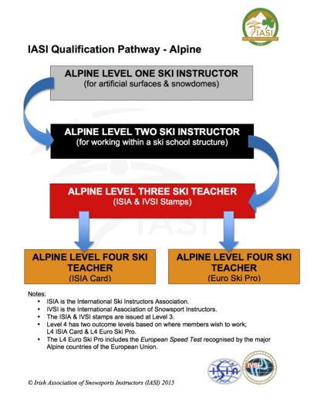

IASI COURSE WORKBOOKS

Published by the Irish Association of Snowsports Instructors

Copyright © IASI 2022

This workbook is the copyright of the Irish Association of Snowsports Instructors. All rights reserved. No part of this publication may be reproduced, stored in any form or by any means electronic, mechanical, recording, and film or otherwise without prior permission of IASI. Update and upgrade material is protected on the same basis.

www.iasisnowsports.ie

First published in 2002 by Derek Tate
IASI

Author
Jamie Kagan
IASI Head of Education
Sara Jones, Fede Sollini, Pete Gillespie
Education Team

The Technical content of this workbook is taken from the Irish Association of Snowsports Instructors Manual and includes CSD model and BP model which are all copyright © Parallel Dreams and used with permission of Parallel Dreams Coaching.

The Teaching Styles referred to in this publication are those developed by Muska Mosston and later Sara Ashworth. See www.spectrumofteachingstyles.org

